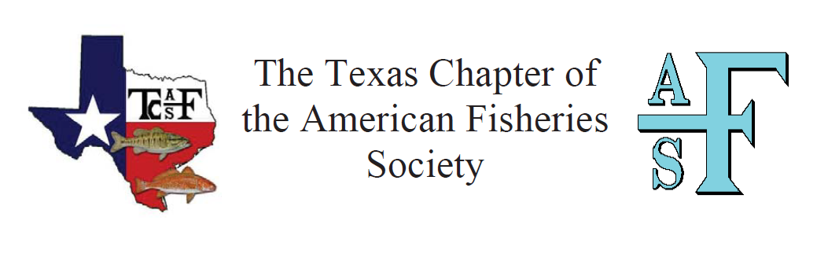
Student Scholarship Application
October 10, 2025
_____________________________________________________________________________________

The Texas Chapter of the American Fisheries Society (TCAFS) is seeking deserving students enrolled in fisheries-related curricula in the State of Texas.

Scholarships in the amount of $2,000 each may be awarded to a minimum of four deserving fisheries students. All degree classifications are eligible: undergraduate, MS, Ph.D. student.
One will be awarded the prestigious Clark Hubbs Scholarship for research that continues his legacy of native fish conservation. One will be awarded the Dave Terre Scholarship which honors his history of contributions to fisheries and TCAFS.

Applicants must be current students at the time of scholarship award (January 2026). Students are eligible to receive one award in each degree category during their scholastic career. No nomination is necessary, and more than one student from the same university may apply in each category. Scholarships will be awarded during the 2026 Texas Chapter of the American Fisheries Society Annual Meeting.

Scholarship recipients will be selected based on their academic excellence, professional activities, promise of future professional involvement, and contributions to the field of fisheries science.

Applications must be received by Sunday, November 9, 2025, 11:59PM CST. A .docx and PDF of the application may be obtained from the TCAFS website. Applications can be submitted as a .docx or PDF by email to Jennifer.Butler@tpwd.texas.gov.

Please direct applications and questions to:
Jennifer Butler – Scholarship Committee Chair
(979) 341-4972 text
Jennifer.Butler@tpwd.texas.gov
Texas Chapter of the American Fisheries Society Scholarship Application Form
Fall 2025 Application for Early 2026 Scholarship Award

Directions: Type all responses and limit your answers to cover the period of your college career only.

1. General Information
Name:
Mailing Address:
Phone Number:
Email Address:
College/University:
Degree/Classification (Undergraduate, Masters, Doctorate):
Overall GPA (most recent):
Expected Graduation Date:

2. List all relevant work and volunteer experience since beginning college-level studies.

3. List honors, fellowships, and scholarships that you have received.

4. List any relevant professional society, scientific society, and honor society activities.

5. Describe ways in which you have exhibited leadership potential. Please limit your response to a maximum of 250 words.

6. Provide a statement describing your career goals. Please limit your response to a maximum of 250 words.

7. Describe your reasons for pursuing a career in fisheries science. Include your personal philosophy of natural resource conservation. Please limit your response to a maximum of 250 words. Your response here is not limited to your college career.

8. If you are currently working on a research project or plan to conduct research as part of your degree, please provide a brief description of your research. If you are not currently working on a research project, then no description is necessary. Please limit your response to a maximum of 350 words.

